**Mobile Application Development Lab**

1. Creating “Hello world” Application.
2. Creating an application that displays message based on the screen orientation.
3. Create an application to develop Login window using UI controls.
4. Create an application to implement new activity using explicit intent, implicit intent and content provider.
5. Create an application that displays custom designed Opening Screen.
6. Create an UI with all views.
7. Create menu in Application
8. Read/ write the Local data.
9. Create / Read / Write data with database (SQLite).
10. Create an application to send SMS and receive SMS
11. Create an application to send an e-mail.
12. Display Map based on the Current/given location.
13. Create a sample application with login module(check user name and password) On successful login change Textview “Login Successful”. On login fail alert using Toast “login fail”
14. Learn to deploy Android applications

**Program 1**

1. Creating “Hello world” Application.
   1. Click **Start** →**Android Studio**, a **Welcome to Android Studio** dialog box will appear. Click **New Project**, the **New Project Dialog box** appears.
   2. Choose **Empty Views Activity** then click **Next**.
   3. Specify the **Name** of your project, Select the **Language** as **Java**, and Select the

**Minimum SDK** as **API 16 (“Jelly Bean”, Android 4.1)**. Click **Finish** Button.

* 1. Create a **Button** resource in **activity_main.xml** and update the following code

*<?*xml version="1.0" encoding="utf-8"*?>*

<androidx.constraintlayout.widget.ConstraintLayout xmlns:andr[oid="http://schemas.android.com/apk/res/android"](http://schemas.android.com/apk/res/android)

xmlns:app=["http://schemas.android.com/apk/res-auto"](http://schemas.android.com/apk/res-auto) xmlns:t[ools="http://schemas.android.com/tools"](http://schemas.android.com/tools) android:layout_width="match_parent" android:layout_height="match_parent" tools:context=".MainActivity">

<Button

**android:id="@+id/hello"** android:layout_width="wrap_content" android:layout_height="wrap_content" **android:background="#535538" android:text="Click Me!"** app:layout_constraintBottom_toBottomOf="parent" app:layout_constraintEnd_toEndOf="parent" app:layout_constraintStart_toStartOf="parent" app:layout_constraintTop_toTopOf="parent" />

</androidx.constraintlayout.widget.ConstraintLayout>

The following figure illustrates the design view of the application.

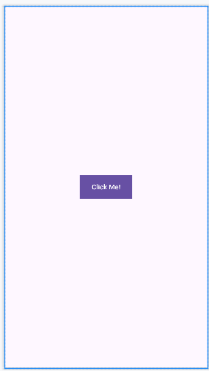

* 1. Create a **Button** object, create **clickListener**, **onClick** event and update the following code in **MainActivity.java**

package com.example.hello_world;

import androidx.appcompat.app.AppCompatActivity; import android.os.Bundle;

import android.view.View; import android.widget.Button; import android.widget.Toast;

public class MainActivity extends AppCompatActivity { @Override

protected void onCreate(Bundle savedInstanceState) { super.onCreate(savedInstanceState); setContentView(R.layout.*activity_main*);

**Button b; b=findViewById(R.id.*hello*);**

**b.setOnClickListener(new View.OnClickListener() { @Override**

**public void onClick(View v) {**

**Toast.*makeText*(MainActivity.this, "Hey! We are using Android Application", Toast.*LENGTH_SHORT*).show();**

}

});

}

}

* 1. Click **Run app** or **shift+F10** to execute the application.

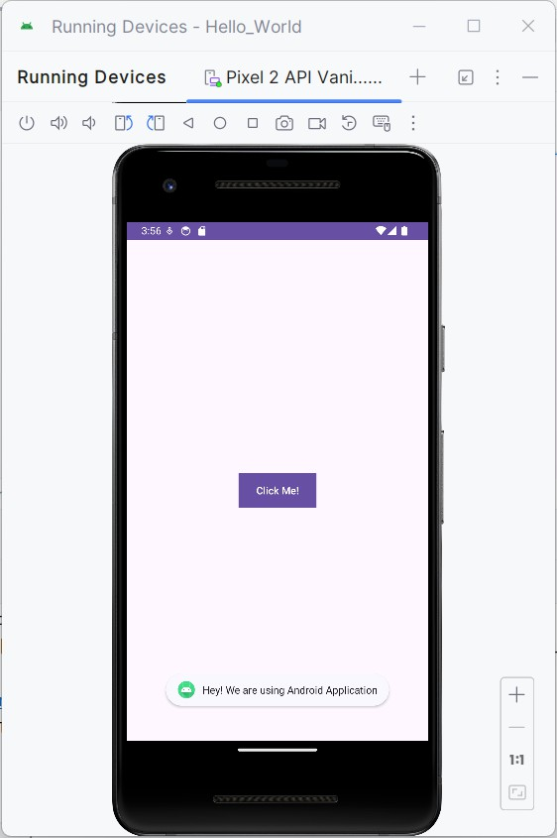**Output:**

**Program 2**

1. Creating an application that displays message based on the screen orientation.
2. Click **Start** →**Android Studio**, a **Welcome to Android Studio** dialog box will appear. Click **New Project**, the **New Project Dialog box** appears.
3. Choose **Empty Views Activity** then click **Next**.
4. Specify the **Name** of your project, Select the **Language** as **Java**, and Select the

**Minimum SDK** as **API 16 (“Jelly Bean”, Android 4.1)**. Click **Finish** Button.

1. Create two **Button** resources in **activity_main.xml** and update the following code.

<?xml version="1.0" encoding="utf-8"?>

<RelativeLayout xmlns:android=["http://schemas.android.com/apk/res/android"](http://schemas.android.com/apk/res/android) xmlns:app=["http://schemas.android.com/apk/res-auto"](http://schemas.android.com/apk/res-auto) xmlns:t[ools="http://schemas.android.com/tools"](http://schemas.android.com/tools)

android:id="@+id/main" android:layout_width="match_parent" android:layout_height="match_parent" tools:context=".MainActivity">

<Button

android:id="@+id/por" android:layout_width="wrap_content" android:layout_height="wrap_content" android:text="Portrait" android:layout_centerInParent="true"/>

<Button

android:id="@+id/lan" android:layout_width="wrap_content" android:layout_height="wrap_content" android:text="Landscape" android:layout_below="@id/por" android:layout_centerInParent="true"/>

</RelativeLayout>

The following figure illustrates the design view of the application.

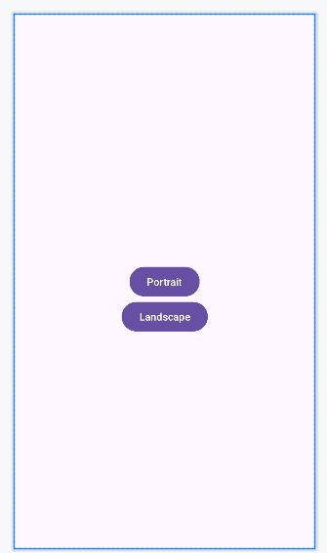

1. Create two **Button** object, create **clickListener**, **onClick** event and update the following code in **MainActivity.java**

package com.example.screen;

import android.content.pm.ActivityInfo; import android.os.Bundle;

import android.view.View; import android.widget.Button; import android.widget.Toast;

import androidx.activity.EdgeToEdge;

import androidx.appcompat.app.AppCompatActivity; import androidx.core.graphics.Insets;

import androidx.core.view.ViewCompat;

import androidx.core.view.WindowInsetsCompat; public class MainActivity extends AppCompatActivity {

@Override

protected void onCreate(Bundle savedInstanceState) { super.onCreate(savedInstanceState); EdgeToEdge.enable(this); setContentView(R.layout.activity_main);

Button l,p; l=findViewById(R.id.*lan*); p=findViewById(R.id.*por*);

l.setOnClickListener(new View.OnClickListener() { @Override

public void onClick(View v) {

setRequestedOrientation(ActivityInfo.*SCREEN_ORIENTATION_LANDSCAPE*);

Toast.*makeText*(MainActivity.this, "Hey! We are in Landscape orientation", Toast.*LENGTH_SHORT*).show();

}

});

p.setOnClickListener(new View.OnClickListener() { @Override

public void onClick(View v) {

setRequestedOrientation(ActivityInfo.*SCREEN_ORIENTATION_PORTRAIT*); Toast.*makeText*(MainActivity.this, "Hey! We are in Portrait orientation",

Toast.*LENGTH_SHORT*).show();

}

});

}

}

1. Click **Run app** or **shift+F10** to execute the application.

**Output**

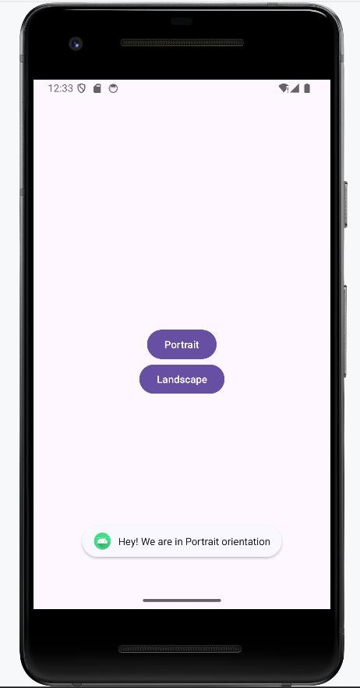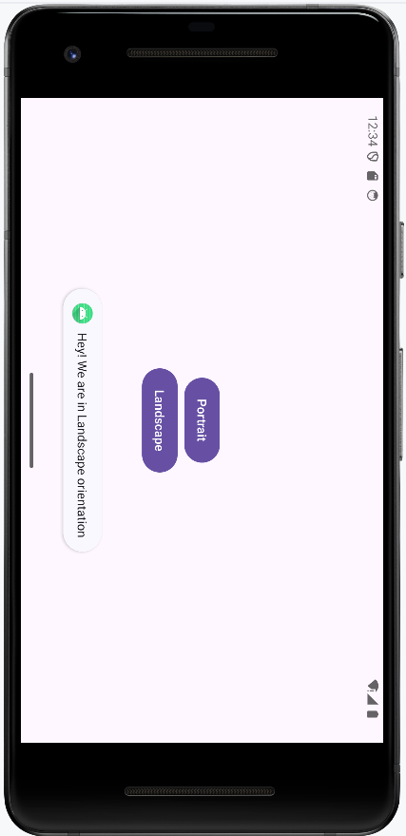

**Program 3**

1. Create an application to develop Login window using UI controls.
2. Click **New Project**, the **New Project Dialog box** appears.
3. Choose **Empty Views Activity** then click **Next**.
4. Specify the **Name** of your project, Select the **Language** as **Java**, and Select the

**Minimum SDK** as **API 16 (“Jelly Bean”, Android 4.1)**. Click **Finish** Button.

1. Create **background** resources(**bg_outer.xml**, **bg_inner.xml**)
   1. To create resource file click **app**→**res**→**drawable.** Right click **drawable**→**New**→ **Drawable Resource File.** The **New Resource File** dialog box appears.
   2. Set **filename** as **bg_outer.xml**, **root element** as **shape** and then click **ok.**

Modify the bg_outer.xml file

<?xml version="1.0" encoding="utf-8"?>

<shape xmlns:android="[http://schemas.android.com/apk/res/android"](http://schemas.android.com/apk/res/android)>

<corners android:radius="12dp" />

<gradient android:startColor="#B388FF" android:endColor="#397C9A"

android:angle="100"/>

</shape>

* 1. Likewise, create another background resource for inner layout. Set **filename** as **bg_inner.xml**, **root element** as **shape** and then click **ok.** Modify the bg_inner.xml file

<?xml version="1.0" encoding="utf-8"?>

<shape xmlns:android="[http://schemas.android.com/apk/res/android"](http://schemas.android.com/apk/res/android)>

<gradient android:startColor="#84FFFF" android:endColor="#f08" android:angle="100"/>

<corners android:radius="20dp"/>

</shape>

1. Create **two EditText box** and **a Button** resource in **activity_main.xml** and update the following code.

<?xml version="1.0" encoding="utf-8"?>

<RelativeLayout xmlns:android=["http://schemas.android.com/apk/res/android"](http://schemas.android.com/apk/res/android) xmlns:app=["http://schemas.android.com/apk/res-auto"](http://schemas.android.com/apk/res-auto) xmlns:t[ools="http://schemas.android.com/tools"](http://schemas.android.com/tools)

android:id="@+id/main" android:layout_width="match_parent" android:layout_height="match_parent" tools:context=".MainActivity" android:background="@drawable/bg_outer">

<LinearLayout android:layout_width="match_parent" android:layout_height="wrap_content" android:gravity="center" android:layout_centerInParent="true" android:orientation="vertical" android:background="@drawable/bg_inner" android:padding="30dp"

>

<TextView android:layout_width="wrap_content" android:layout_height="wrap_content" android:text="LOGIN PAGE" android:textSize="32sp" android:textStyle="bold"

android:fontFamily="sans-serif-condensed-medium" android:textColor="@color/black" android:paddingBottom="20dp"

/>

<EditText android:id="@+id/editTextUsername" android:layout_width="match_parent"

android:layout_height="wrap_content" android:hint="Username" android:layout_marginBottom="16dp"/>

<EditText android:id="@+id/editTextPassword" android:layout_width="match_parent" android:layout_height="wrap_content" android:hint="Password"

android:layout_below="@id/editTextUsername" android:layout_marginBottom="16dp" android:inputType="textPassword"/>

<Button

android:id="@+id/buttonLogin" android:layout_width="wrap_content" android:layout_height="wrap_content" android:text="Login" android:layout_below="@id/editTextPassword"/>

</LinearLayout>

</RelativeLayout>

The following figure illustrates the design view of the application.

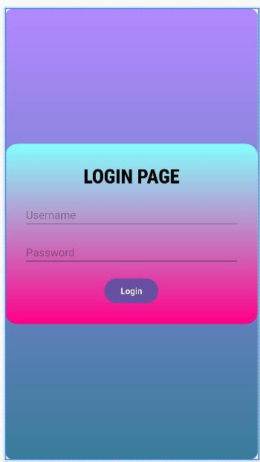

1. Create two **EditText** and a **Button** object, create **clickListener**, **onClick** event for button object and update the following code in **MainActivity.java**

package com.example.controls;

import android.os.Bundle; import android.view.View; import android.widget.Button; import android.widget.EditText; import android.widget.Toast;

import androidx.activity.EdgeToEdge;

import androidx.appcompat.app.AppCompatActivity; import androidx.core.graphics.Insets;

import androidx.core.view.ViewCompat;

import androidx.core.view.WindowInsetsCompat;

public class MainActivity extends AppCompatActivity { private EditText editTextUsername,editTextPassword; private Button buttonLogin;

@Override

protected void onCreate(Bundle savedInstanceState) { super.onCreate(savedInstanceState); EdgeToEdge.enable(this); setContentView(R.layout.activity_main);

editTextUsername = findViewById(R.id.*editTextUsername*); editTextPassword = findViewById(R.id.*editTextPassword*); buttonLogin = findViewById(R.id.*buttonLogin*); buttonLogin.setOnClickListener(new View.OnClickListener() {

@Override

public void onClick(View v) {

String username = editTextUsername.getText().toString().trim(); String password = editTextPassword.getText().toString().trim();

if(username.equals("admin") && password.equals("pass")){ Toast.*makeText*(MainActivity.this, "Login successful",

Toast.*LENGTH_SHORT*).show();

} else {

Toast.*makeText*(MainActivity.this, "Invalid username or password", Toast.*LENGTH_SHORT*).show();

}

}

});

}

}

1. Click **Run app** or **shift+F10** to execute the application.

**Output**

St. Claret College, MES Ring Road, Jalahalli, Bangalore-13

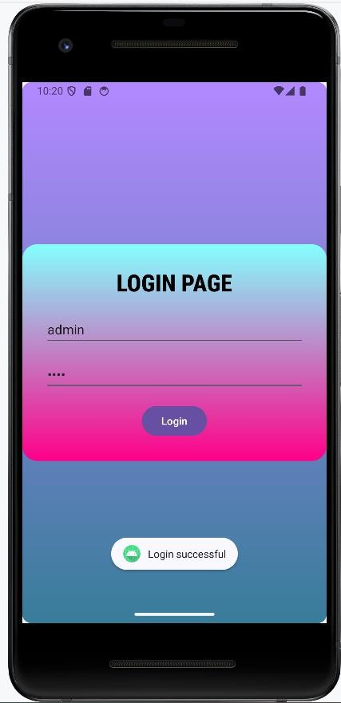 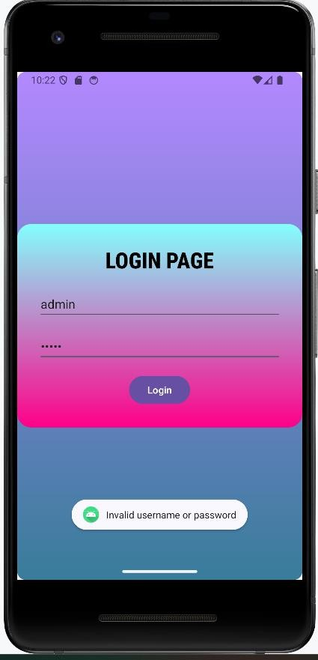

**Program 4**

1. Create an application to implement new activity using explicit intent, implicit intent and content provider.
2. Click **New Project**, the **New Project Dialog box** appears.
3. Choose **Empty Views Activity** then click **Next**.
4. Specify the **Name** of your project, Select the **Language** as **Java**, and Select the

**Minimum SDK** as **API 16 (“Jelly Bean”, Android 4.1)**. Click **Finish** Button.

1. To create another activity for **Explicit Intent,** Click **File**→**New**→**Activity**→ **Empty Views Activity.** A **New Android Activity** dialog box appears, Specify the **Name** of the activity as **NewActivity** then click **Finish**.
2. Create one **TextView** resource in **activity_new.xml** and update the following code

<?xml version="1.0" encoding="utf-8"?>

<androidx.constraintlayout.widget.ConstraintLayout xmlns:andr[oid="http://schemas.android.com/apk/res/android"](http://schemas.android.com/apk/res/android)

xmlns:app=["http://schemas.android.com/apk/res-auto"](http://schemas.android.com/apk/res-auto) xmlns:t[ools="http://schemas.android.com/tools"](http://schemas.android.com/tools) android:id="@+id/main" android:layout_width="match_parent" android:layout_height="match_parent" tools:context=".NewActivity">

<TextView android:id="@+id/textView" android:layout_width="wrap_content"

android:layout_height="wrap_content" android:text="Welcome to Explicit Intent" android:textSize="28sp" app:layout_constraintBottom_toBottomOf="parent" app:layout_constraintEnd_toEndOf="parent" app:layout_constraintStart_toStartOf="parent" app:layout_constraintTop_toTopOf="parent" />

</androidx.constraintlayout.widget.ConstraintLayout>

The following figure illustrates the design view of the application(**activity_new.xml**).

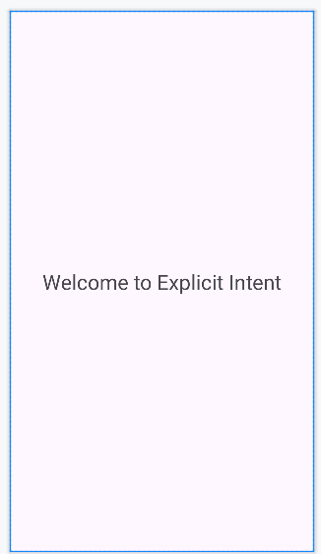

1. Add two events named as **onImplicitButtonClicked, onExplicitButtonClicked** and update the following code in **MainActivity.java**

package com.example.intentexample;

import android.content.Intent; import android.net.Uri; import android.os.Bundle; import android.view.View;

import androidx.activity.EdgeToEdge;

import androidx.appcompat.app.AppCompatActivity; import androidx.core.graphics.Insets;

import androidx.core.view.ViewCompat;

import androidx.core.view.WindowInsetsCompat; public class MainActivity extends AppCompatActivity {

@Override

protected void onCreate(Bundle savedInstanceState) { super.onCreate(savedInstanceState); EdgeToEdge.enable(this); setContentView(R.layout.activity_main);

}

public void onImplicitButtonClicked(View view)

{

Uri url=Uri.*parse*("https://[www.google.com"](http://www.google.com/)); Intent i=new Intent(Intent.*ACTION_VIEW*, url); startActivity(i);

}

public void onExplicitButtonClicked(View view )

{

Intent i=new Intent(MainActivity.this, NewActivity.class); startActivity(i);

}

}

1. Add **two Button** resource in **activity_main.xml** and update the following code.

<?xml version="1.0" encoding="utf-8"?>

<LinearLayout xmlns:andr[oid="http://schemas.android.com/apk/res/android"](http://schemas.android.com/apk/res/android) xmlns:app=["http://schemas.android.com/apk/res-auto"](http://schemas.android.com/apk/res-auto) xmlns:t[ools="http://schemas.android.com/tools"](http://schemas.android.com/tools)

android:id="@+id/main" android:layout_width="match_parent" android:layout_height="match_parent" android:gravity="center" tools:context=".MainActivity">

<Button

android:layout_width="wrap_content" android:layout_height="wrap_content" android:text="Implicit Intent" android:onClick="onImplicitButtonClicked"

/>

<Button

android:layout_width="wrap_content" android:layout_height="wrap_content" android:text="Explicit Intent" android:onClick="onExplicitButtonClicked"/>

</LinearLayout>

The following figure illustrates the design view of the application(**activity_main.xml**).

St. Claret College, MES Ring Road, Jalahalli, Bangalore-13

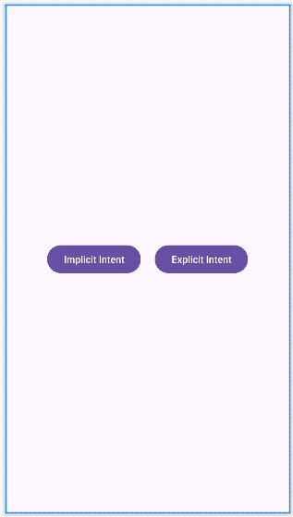

1. Click **Run app** or **shift+F10** to execute the application.

**Output**

**For Implicit Intent**

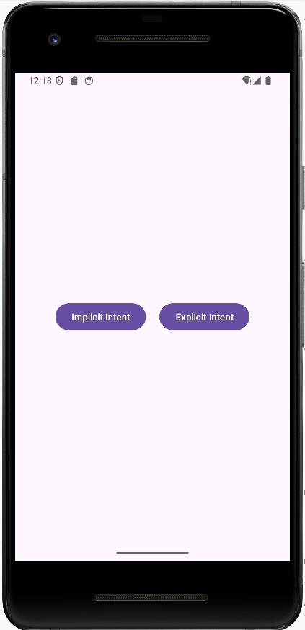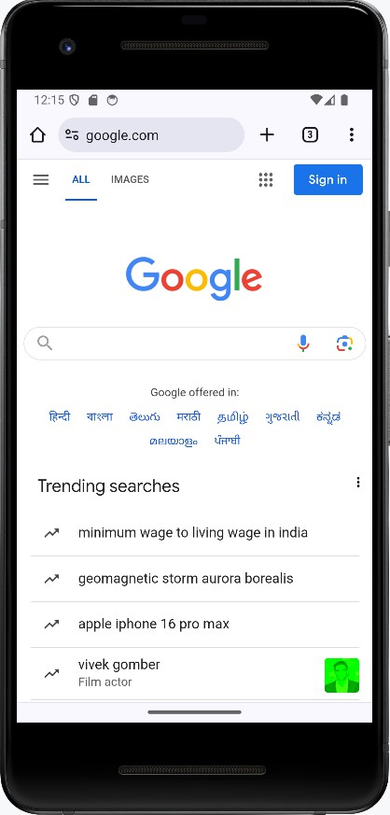

**For Explicit Intent**

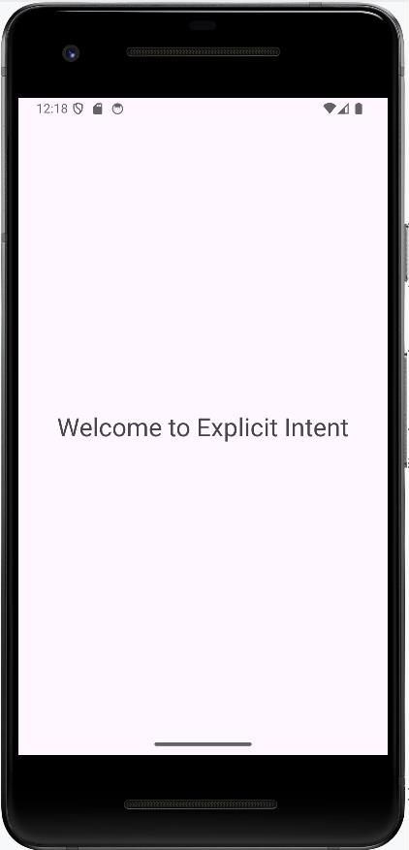

**Program 5**

1. Create an application that displays custom designed Opening Screen.
2. Click **New Project**, the **New Project Dialog box** appears.
3. Choose **Empty Views Activity** then click **Next**.
4. Specify the **Name** of your project, Select the **Language** as **Java**, and Select the

**Minimum SDK** as **API 16 (“Jelly Bean”, Android 4.1)**. Click **Finish** Button.

1. To create another activity for **Home Page,** Right Click **App**→**New**→**Activity**→ **Empty Views Activity.** A **New Android Activity** dialog box appears, Specify the **Name** of the activity as **mainScreen** then click **Finish**.
2. Create one **TextView** resource in **activity_mainScreen.xml** and update the following code

*<?*xml version="1.0" encoding="utf-8"*?>*

<RelativeLayout xmlns:android=["http://schemas.android.com/apk/res/android"](http://schemas.android.com/apk/res/android) xmlns:app=["http://schemas.android.com/apk/res-auto"](http://schemas.android.com/apk/res-auto) xmlns:t[ools="http://schemas.android.com/tools"](http://schemas.android.com/tools)

android:id="@+id/main" android:layout_width="match_parent" android:layout_height="match_parent" tools:context=".mainscreen" android:gravity="center"

android:background="#7E6C29">

<TextView android:layout_width="wrap_content" android:layout_height="wrap_content" android:text="Welcome to home Page" android:textStyle="bold" android:textSize="32sp" android:textColor="@color/black"/>

</RelativeLayout>

The following figure illustrates the design view of the application(**activity_mainScreen.xml**).

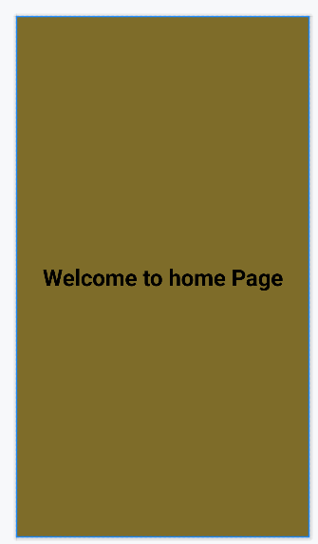

1. **To add an ImageView resource:** Copy an image and paste it into **drawable folder (**Right-click **Drawable**→ **Paste** the image**[img1.jpg]**).
2. Set an **image** as **src** in **activity_main.xml** and update the following code.

*<?*xml version="1.0" encoding="utf-8"*?>*

<RelativeLayout xmlns:android=["http://schemas.android.com/apk/res/android"](http://schemas.android.com/apk/res/android) xmlns:app=["http://schemas.android.com/apk/res-auto"](http://schemas.android.com/apk/res-auto) xmlns:t[ools="http://schemas.android.com/tools"](http://schemas.android.com/tools)

android:id="@+id/main" android:layout_width="match_parent" android:layout_height="match_parent" tools:context=".MainActivity" android:gravity="center">

<ImageView android:layout_width="wrap_content" android:layout_height="wrap_content" android:src="@drawable/img_1"/>

</RelativeLayout>

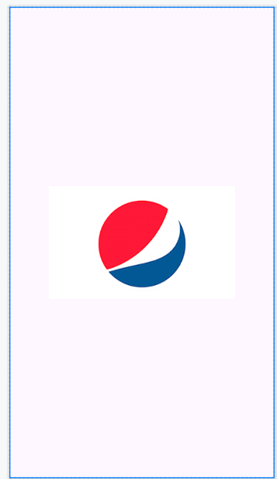The following figure illustrates the design view of the application(**activity_HomeScreen.xml**).

1. Update the following code in **MainActivity.java**

package com.example.pgm3;

import android.content.Intent; import android.os.Bundle; import android.os.Handler;

import android.view.WindowManager; import androidx.activity.EdgeToEdge;

import androidx.appcompat.app.AppCompatActivity; import androidx.core.graphics.Insets;

import androidx.core.view.ViewCompat;

import androidx.core.view.WindowInsetsCompat;

public class MainActivity extends AppCompatActivity {

private static final int *SPLASH_SCREEN_TIME_OUT* = 2000; @Override

protected void onCreate(Bundle savedInstanceState) { super.onCreate(savedInstanceState); EdgeToEdge.*enable*(this); setContentView(R.layout.*activity_main*);

getWindow().setFlags(WindowManager.LayoutParams.*FLAG_FULLSCREEN*, WindowManager.LayoutParams.*FLAG_FULLSCREEN*);

new Handler().postDelayed(new Runnable() { @Override

public void run() {

Intent i = new Intent(MainActivity.this, mainscreen.class); startActivity(i);

finish();

}

}, *SPLASH_SCREEN_TIME_OUT*);

}

}

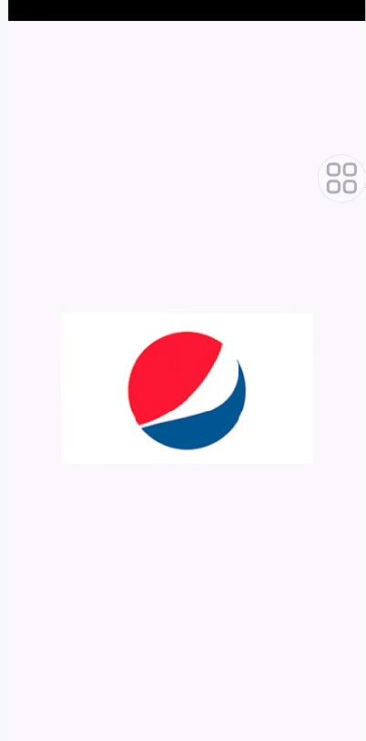 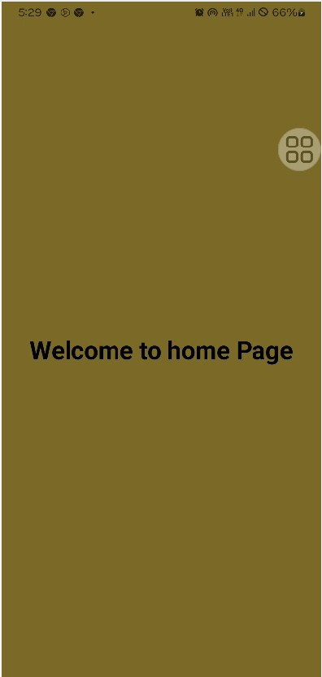

**Program 6**

1. Create an UI with all views.
   1. Click **New Project**, the **New Project Dialog box** appears.
   2. Choose **Empty Views Activity** then click **Next**.
   3. Specify the **Name** of your project, Select the **Language** as **Java**, and Select the

**Minimum SDK** as **API 16 (“Jelly Bean”, Android 4.1)**. Click **Finish** Button.

* 1. Create **background** resources(**bg_outer.xml**, **bg_inner.xml, bg.xml**)
     1. To create resource file click **app**→**res**→**drawable.** Right click **drawable**→**New**→ **Drawable Resource File.** The **New Resource File** dialog box appears.
     2. Set **filename** as **bg_outer.xml**, **root element** as **shape** and then click **ok.**

Modify the bg_outer.xml file

*<?*xml version="1.0" encoding="utf-8"*?>*

<shape xmlns:android="[http://schemas.android.com/apk/res/android"](http://schemas.android.com/apk/res/android)>

<gradient android:startColor="#64EFAE" android:endColor="#84FFFF" android:angle="120" android:gradientRadius="5dp"/>

<corners android:radius="20dp"/>

</shape>

* + 1. Create another background resource for inner layout. Set **filename** as **bg_inner.xml**, **root element** as **shape** and then click **ok.** Modify the bg_inner.xml file

*<?*xml version="1.0" encoding="utf-8"*?>*

<shape xmlns:android="[http://schemas.android.com/apk/res/android"](http://schemas.android.com/apk/res/android)>

<gradient android:startColor="#64F194" android:endColor="#B242C5" android:angle="120" android:gradientRadius="5dp"/>

<corners android:radius="20dp" android:topLeftRadius="70dp" android:bottomRightRadius="70dp"/>

</shape>

* + 1. Likewise, create another background resource for view. Set **filename** as **bg.xml**, **root element** as **shape** and then click **ok.** Modify the bg..xml file

*<?*xml version="1.0" encoding="utf-8"*?>*

<shape xmlns:android="[http://schemas.android.com/apk/res/android"](http://schemas.android.com/apk/res/android)>

<solid android:color="#2860F367"/>

<corners android:radius="30dp" />

<stroke android:color="#00BFA5" android:width="2dp"/>

</shape>

* 1. Create a **TextView, EditText, ToggleButton, ImageView, RadioGroup, RadioButton, spinner** and **a Button** resource in **activity_main.xml** and update the following code.

*<?*xml version="1.0" encoding="utf-8"*?>*

<LinearLayout xmlns:android=["http://schemas.android.com/apk/res/android"](http://schemas.android.com/apk/res/android) xmlns:app=["http://schemas.android.com/apk/res-auto"](http://schemas.android.com/apk/res-auto) xmlns:t[ools="http://schemas.android.com/tools"](http://schemas.android.com/tools)

android:id="@+id/main" android:layout_width="match_parent" android:layout_height="match_parent" tools:context=".MainActivity" android:gravity="center" android:orientation="vertical" android:padding="30dp" android:background="@drawable/bg_outer">

<TextView android:layout_width="wrap_content" android:layout_height="wrap_content" android:text="User Information" android:textSize="30sp" android:textStyle="bold" android:textColor="#26389C"/>

<ImageView android:layout_width="wrap_content" android:layout_height="wrap_content" android:src="@drawable/account_img"/>

<ToggleButton android:layout_width="wrap_content" android:layout_height="wrap_content" android:textOn="Active" android:textOff="Inactive"/>

<View

android:layout_width="match_parent" android:layout_height="40dp"/>

<LinearLayout android:layout_width="match_parent" android:layout_height="wrap_content" android:paddingTop="30dp" android:paddingBottom="30dp" android:paddingLeft="5dp" android:paddingRight="5dp" android:orientation="vertical" android:background="@drawable/bg_inner">

<LinearLayout android:layout_width="match_parent" android:layout_height="wrap_content" android:orientation="horizontal" android:padding="5dp">

<TextView

android:layout_width="wrap_content" android:layout_height="wrap_content" android:text="Name" android:textSize="20sp" android:textStyle="bold" android:textColor="#26389C" android:padding="15dp"/>

<EditText

android:layout_width="match_parent" android:layout_height="60dp" android:id="@+id/name" android:background="@drawable/bg" android:padding="15dp"/>

</LinearLayout>

<LinearLayout

android:layout_width="match_parent" android:layout_height="wrap_content" android:orientation="horizontal" android:padding="5dp">

<TextView

android:layout_width="wrap_content" android:layout_height="wrap_content" android:text="E-mail" android:textSize="20sp" android:textStyle="bold"

android:textColor="#26389C" android:padding="15dp"/>

<EditText

android:id="@+id/email" android:layout_width="match_parent" android:layout_height="60dp" android:ems="10" android:inputType="textEmailAddress" android:background="@drawable/bg" android:padding="15dp"/>

</LinearLayout>

<LinearLayout android:layout_width="match_parent" android:layout_height="wrap_content" android:orientation="horizontal" android:padding="5dp">

<TextView android:layout_width="wrap_content" android:layout_height="wrap_content" android:text="Sex" android:textSize="20sp" android:textStyle="bold" android:textColor="#26389C" android:padding="15dp" android:paddingEnd="40dp"

/>

<RadioGroup android:layout_width="wrap_content" android:layout_height="wrap_content" android:background="@drawable/bg" android:orientation="horizontal" android:id="@+id/sex">

<RadioButton android:layout_width="wrap_content" android:layout_height="wrap_content" android:id="@+id/male" android:padding="15dp" android:text="Male" android:textColor="#26389C" android:textSize="20sp" android:textStyle="bold" />

<RadioButton android:layout_width="wrap_content" android:layout_height="wrap_content" android:id="@+id/female" android:padding="15dp"

android:text="Female" android:textColor="#26389C" android:textSize="20sp" android:textStyle="bold" />

</RadioGroup>

</LinearLayout>

<LinearLayout android:layout_width="match_parent" android:layout_height="wrap_content" android:orientation="horizontal" android:padding="5dp">

<TextView

android:layout_width="wrap_content" android:layout_height="wrap_content" android:text="Country" android:textSize="20sp" android:textStyle="bold" android:textColor="#26389C" android:padding="15dp" android:paddingEnd="5dp" />

<Spinner

android:layout_width="match_parent" android:layout_height="60dp" android:id="@+id/country" android:padding="15dp" android:background="@drawable/bg"/>

</LinearLayout>

</LinearLayout>

<View

android:layout_width="match_parent" android:layout_height="40dp"/>

<Button

android:layout_width="210dp" android:layout_height="wrap_content" android:id="@+id/submit" android:background="@drawable/bg" android:padding="15dp" android:text="Submit" android:textColor="#26389C" android:textSize="20sp" android:textStyle="bold" />

</LinearLayout>

The following figure illustrates the design view of the application.

St. Claret College, MES Ring Road, Jalahalli, Bangalore-13

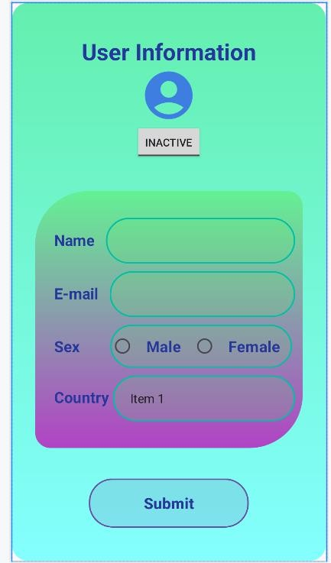

* 1. Create two **EditText** and a **Button** object, create **clickListener**, **onClick** event for button object and update the following code in **MainActivity.java**

package com.example.all_views;

import android.app.Dialog; import android.content.Context;

import android.content.DialogInterface; import android.os.Bundle;

import android.view.View; import android.view.ViewGroup;

import android.widget.ArrayAdapter; import android.widget.Button; import android.widget.EditText; import android.widget.RadioButton; import android.widget.RadioGroup; import android.widget.Spinner; import android.widget.Toast;

import androidx.activity.EdgeToEdge; import androidx.appcompat.app.AlertDialog;

St. Claret College, MES Ring Road, Jalahalli, Bangalore-13

import androidx.appcompat.app.AppCompatActivity; import androidx.core.graphics.Insets;

import androidx.core.view.ViewCompat;

import androidx.core.view.WindowInsetsCompat;

public class MainActivity extends AppCompatActivity { Button sub;

@Override

protected void onCreate(Bundle savedInstanceState) { super.onCreate(savedInstanceState); EdgeToEdge.*enable*(this); setContentView(R.layout.*activity_main*);

Button sub=findViewById(R.id.*submit*);

sub.setOnClickListener(new View.OnClickListener() { @Override

public void onClick(View v) { showMessage(MainActivity.this,"User Information","Successfully

completed");

}

});

String[] item=new String[]{"India", "Pakisthan", "China", "America", "England"};

ArrayAdapter adapter = new ArrayAdapter<>(this, android.R.layout.*simple_spinner_item*, item);

adapter.setDropDownViewResource(android.R.layout.*simple_spinner_dropdown_i tem*);

Spinner spinner = findViewById(R.id.*country*); spinner.setAdapter(adapter);

}

public void showMessage(Context con,String t, String msg)

{

AlertDialog.Builder builder = new AlertDialog.Builder(con); builder.setTitle(t);

builder.setMessage(msg);

builder.setPositiveButton("OK", new DialogInterface.OnClickListener() { @Override

public void onClick(DialogInterface dialog, int which) { dialog.dismiss();

}

});

builder.show();

}

}

* 1. Click **Run app** or **shift+F10** to execute the application.

**Output**

St. Claret College, MES Ring Road, Jalahalli, Bangalore-13

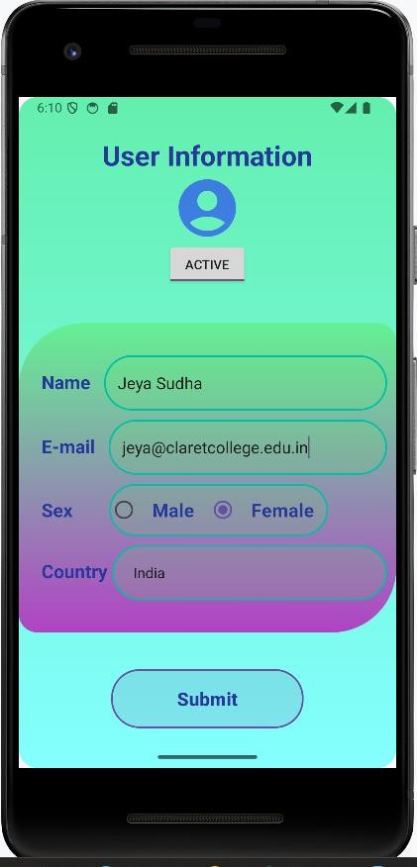 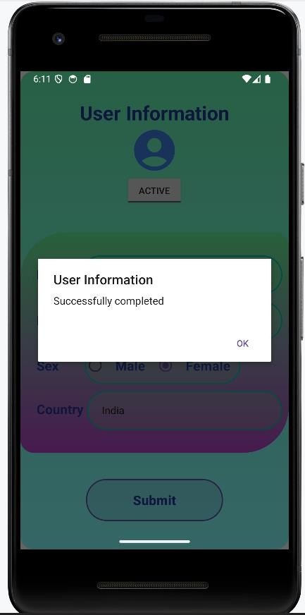

**Program 7**

1. Create menu in Application
   1. Click **New Project**, the **New Project Dialog box** appears.
   2. Choose **Empty Views Activity** then click **Next**.
   3. Specify the **Name** of your project, Select the **Language** as **Java**, and Select the

**Minimum SDK** as **API 16 (“Jelly Bean”, Android 4.1)**. Click **Finish** Button.

* 1. To create another activity for **Home Page,** Right Click **App**→**New**→**Activity**→ **Empty Views Activity.** A **New Android Activity** dialog box appears, Specify the **Name** of the activity as **HomeScreen** then click **Finish**.
  2. **To create a Menu Resource File:**

Right-click on the **res** directory in your Android project, navigate to **New > Android Resource File**, and **name** the file **menus.xml**, Root element as **Menu** and update the following content.

*<?*xml version="1.0" encoding="utf-8"*?>*

<menu xmlns:android="[http://schemas.android.com/apk/res/android"](http://schemas.android.com/apk/res/android)>

<item android:id="@+id/php" android:title="PHP"/>

<item android:id="@+id/java"

android:title="JAVA"/>

<item android:id="@+id/csharp" android:title="C#"/>

</menu>

The menu design is as follows:

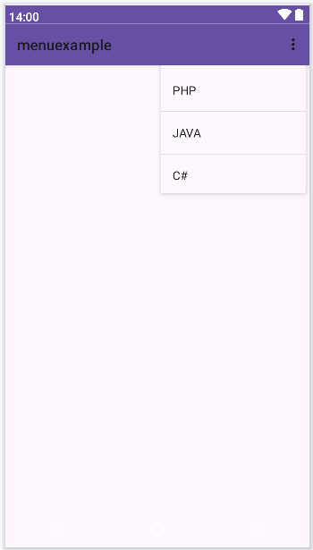

* 1. Update the following code in **MainActivity.java**

package com.example.menuexample; import android.content.Intent;

import android.os.Bundle; import android.view.Menu;

import android.view.MenuInflater; import android.view.MenuItem; import android.widget.Toast;

import androidx.activity.EdgeToEdge; import androidx.annotation.NonNull;

import androidx.appcompat.app.AppCompatActivity; import androidx.core.graphics.Insets;

import androidx.core.view.ViewCompat;

import androidx.core.view.WindowInsetsCompat; public class MainActivity extends AppCompatActivity {

@Override

protected void onCreate(Bundle savedInstanceState) { super.onCreate(savedInstanceState); EdgeToEdge.*enable*(this);

setContentView(R.layout.*activity_main*);

}

@Override

public boolean onCreatePanelMenu(int featureId, @NonNull Menu menu) { MenuInflater inflater=getMenuInflater(); inflater.inflate(R.menu.*menus*,menu);

return true;

}

@Override

public boolean onOptionsItemSelected(@NonNull MenuItem item) { if(item.getItemId()==R.id.*php*) {

Toast.*makeText*(this, "Php Page", Toast.*LENGTH_SHORT*).show();

}

if(item.getItemId()==R.id.*java*) {

Toast.*makeText*(this, "Java Page", Toast.*LENGTH_SHORT*).show();

}

if(item.getItemId()==R.id.*csharp*) {

Toast.*makeText*(this, "C# Page", Toast.*LENGTH_SHORT*).show();

}

return super.onOptionsItemSelected(item);

}

}

* 1. Set the **Uses-Permission** in **AndroidManifest.xml**

*<?*xml version="1.0" encoding="utf-8"*?>*

<manifest xmlns:android=["http://schemas.android.com/apk/res/android"](http://schemas.android.com/apk/res/android) xmlns:tools=["http://schemas.android.com/tools">](http://schemas.android.com/tools)

<uses-permission android:name="android.permission.INTERNET" />

<application android:allowBackup="true"

android:dataExtractionRules="@xml/data_extraction_rules" android:fullBackupContent="@xml/backup_rules" android:icon="@mipmap/ic_launcher" android:label="@string/app_name" android:roundIcon="@mipmap/ic_launcher_round" android:supportsRtl="true" android:theme="@style/Theme.AppCompat.Light" tools:targetApi="31">

<activity android:name=".MainActivity" android:exported="true">

<intent-filter>

<action android:name="android.intent.action.MAIN" />

<category android:name="android.intent.category.LAUNCHER" />

</intent-filter>

</activity>

</application>

</manifest>

* 1. Click **Run app** or **shift+F10** to execute the application.

**Output**

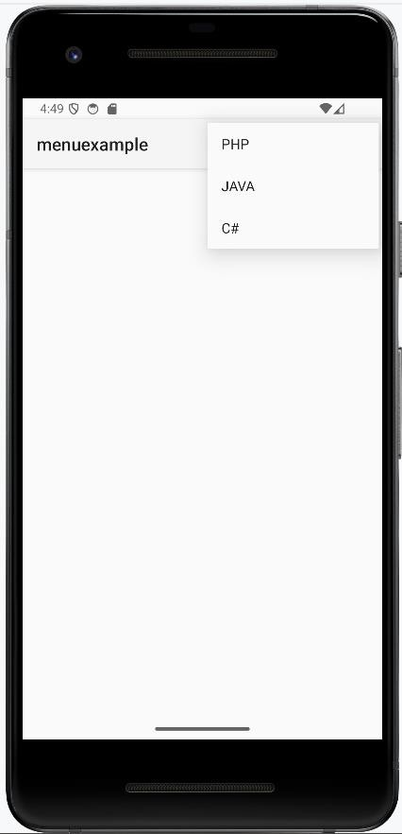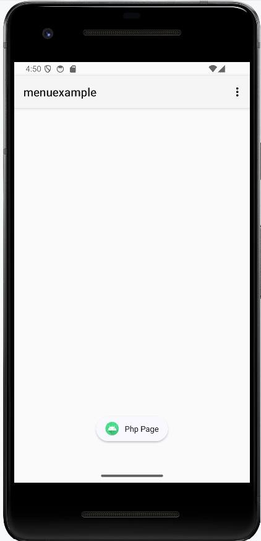

St. Claret College, MES Ring Road, Jalahalli, Bangalore-13

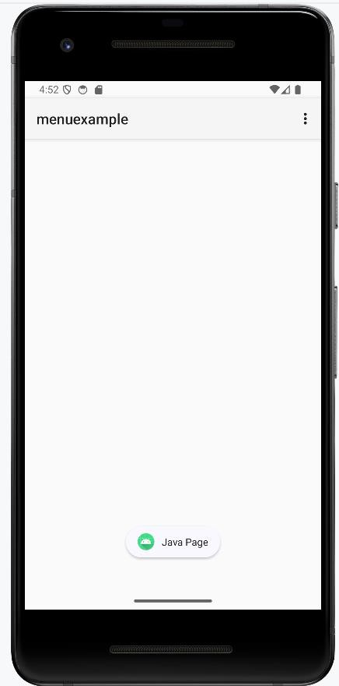 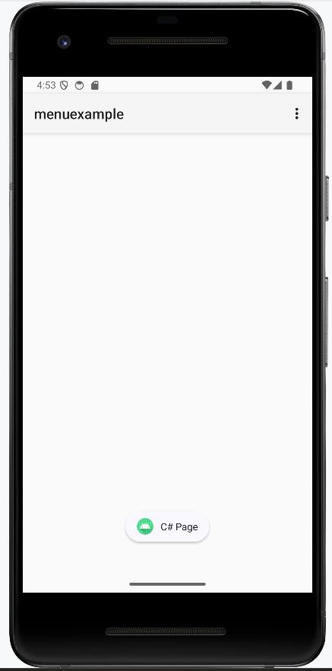

1. Read/ write the Local data.
2. Create / Read / Write data with database (SQLite).
3. Create an application to send SMS and receive SMS
4. Create an application to send an e-mail.
5. Display Map based on the Current/given location.
6. Create a sample application with login module(check user name and password) On successful login change Textview “Login Successful”. On login fail alert using Toast “login fail”
7. Learn to deploy Android applications